

**Experiment No.: 04**

**Title:** Programing with Jenkins

**Batch: A1 Roll No.: 1814068 Experiment No.:0**4 **Aim:** To execute Java/ Python program with Jenkins.

**Resources needed:** Jenkins, Java/Python compiler

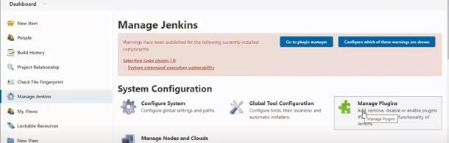

**Theory:**

**Manage plugins:** To install plugins for integration with Jenkins.

**Global Tool Configuration:** To Configure plugins for integration with Jenkins

.

# Procedure:

1. Install any Java/Python compiler on the computer and set path.

# Python Programming

1. Create a python program and run/check on cmd [program without user input]
2. Create Jenkins->new view-> expt4
3. Install Python plugins from Jenkins->Manage Jenkins->Manage plugins->python
4. Restart Jenkins
   1. Windows: run->systemctl.msc->Jenkinns->restart
   2. Ubuntu command: systemctl Jenkinns restart
5. Configure Jenkins->Manage Jenkins->global tool configuration->python

# Programming

* 1. **Implicit:** writing code inside the Jenkins
     1. Create New item-> freestyle project->build tab, write python script and build
  2. **Explicit:** writing code outside the Jenkins
     1. Create New item-> freestyle project>build tab, write window batch command and build

# Java parametrized Programming [Explicit only]

1. Create New item-> freestyle project this project is parametrized
2. Set two string parameter num1 and num2
3. Select build tab->window batch command, write command and build

# Results: (Document with screenshots)

1. All steps to install python plugin and configuration.
2. All steps to execute Implicit and Explicit python program.
3. All steps to execute Explicit java parametrized program.

**Python (Explicit)**

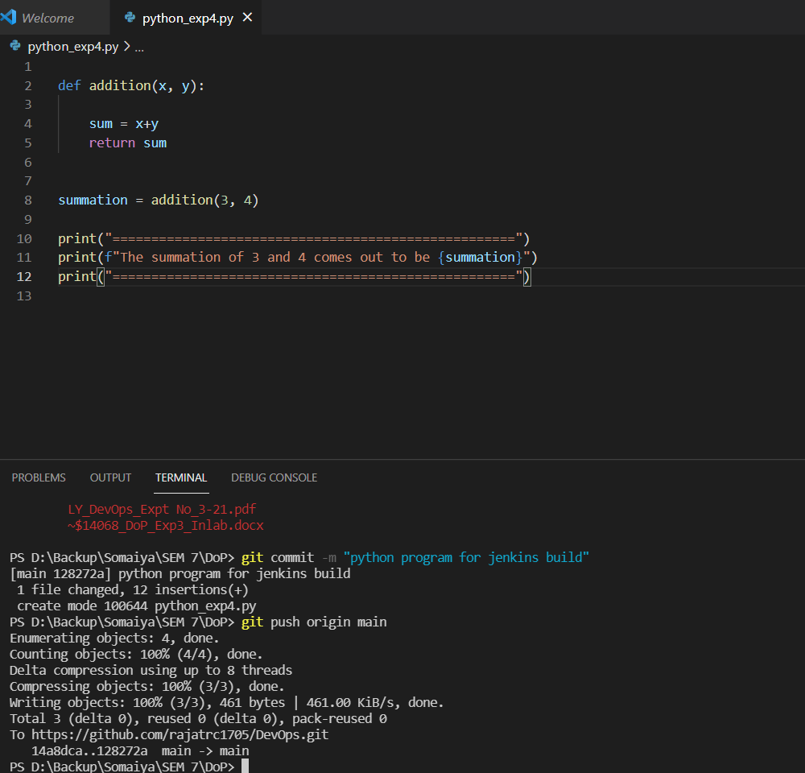

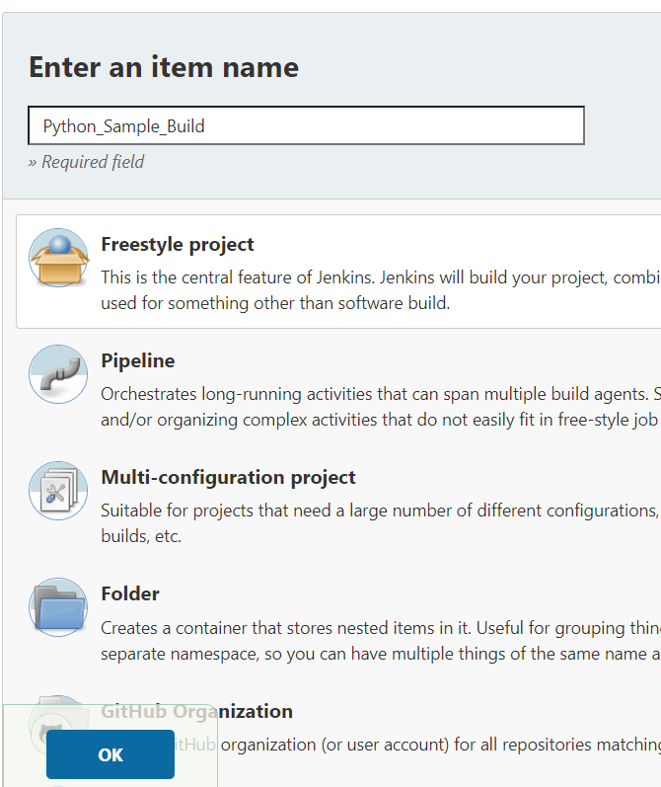

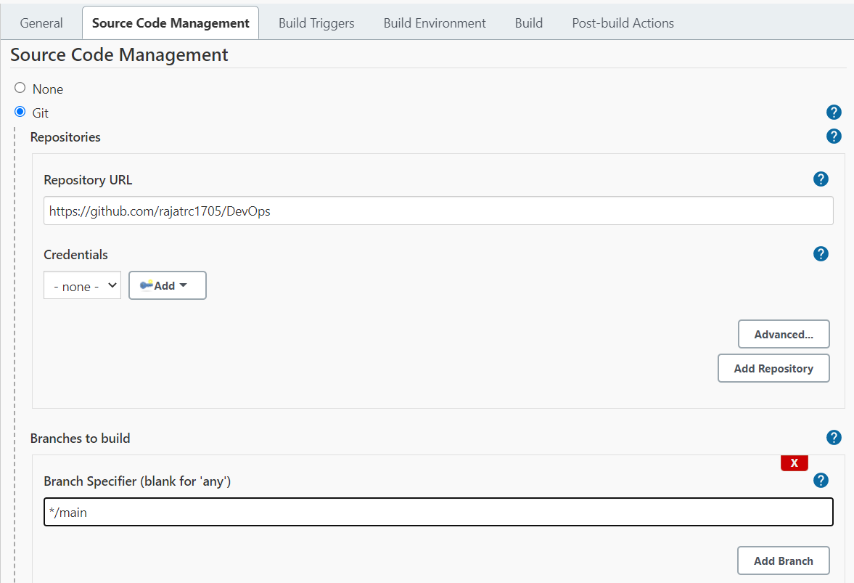 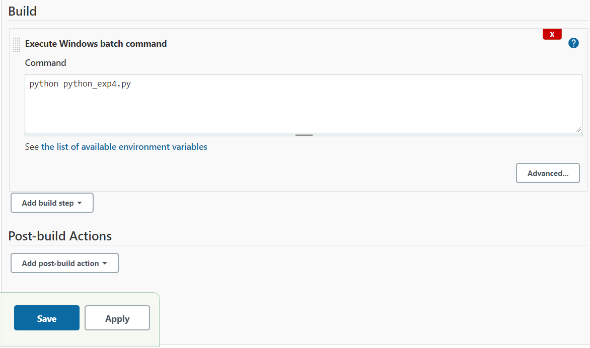 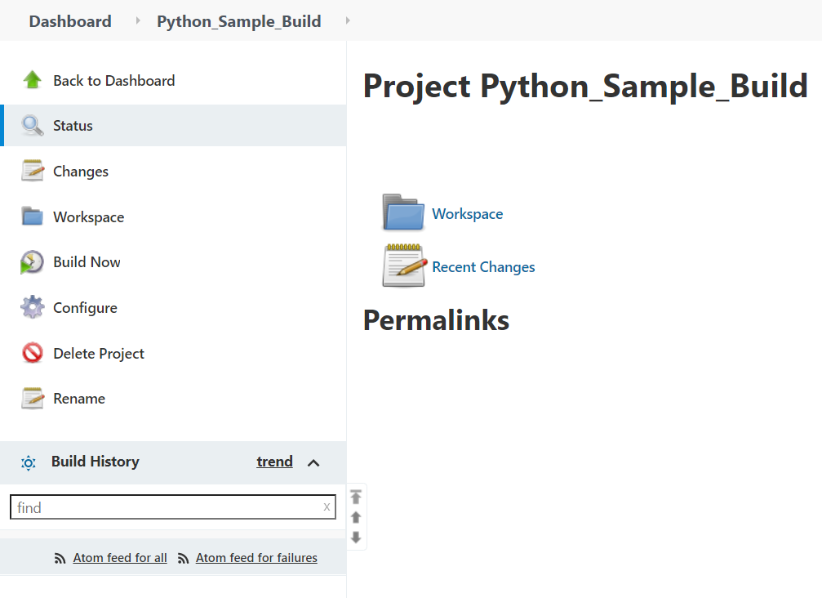 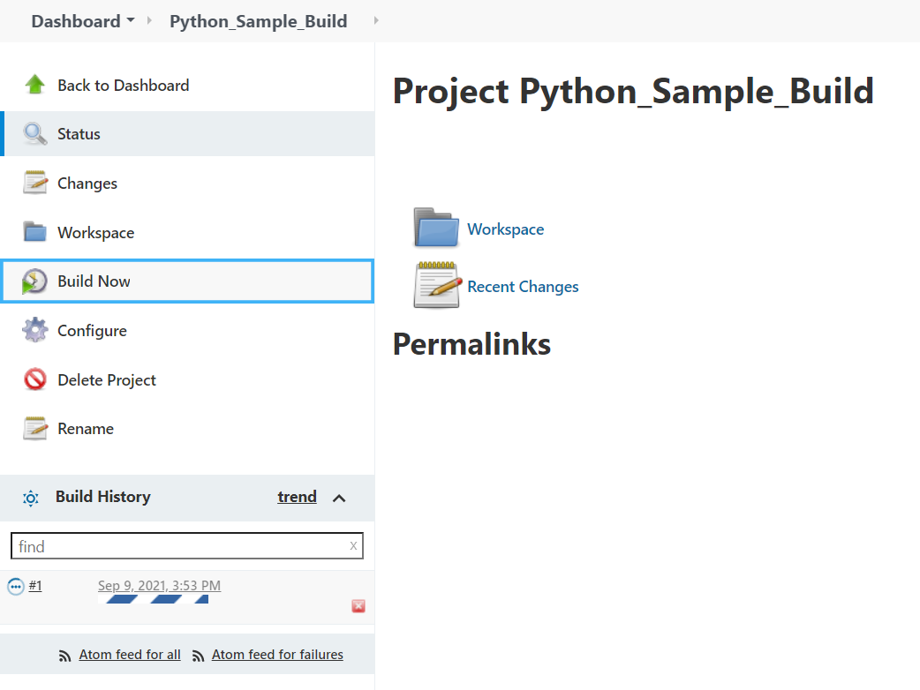

Output 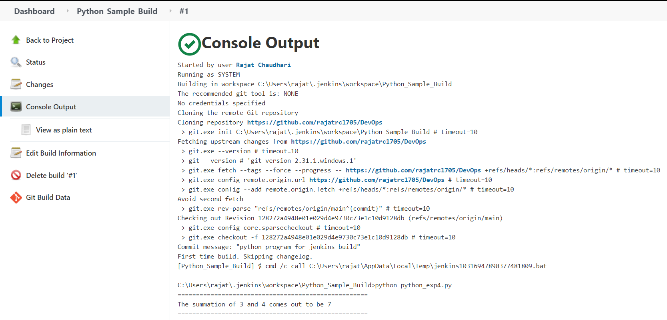 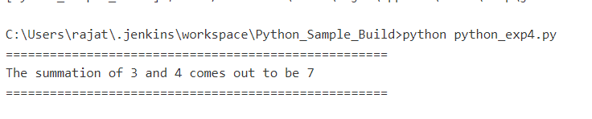

**Python (Implicit)**

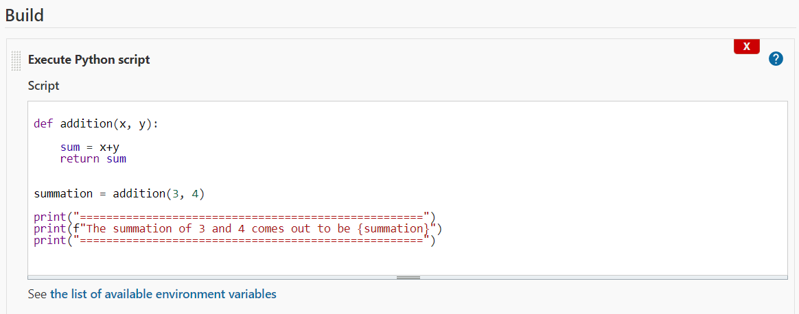

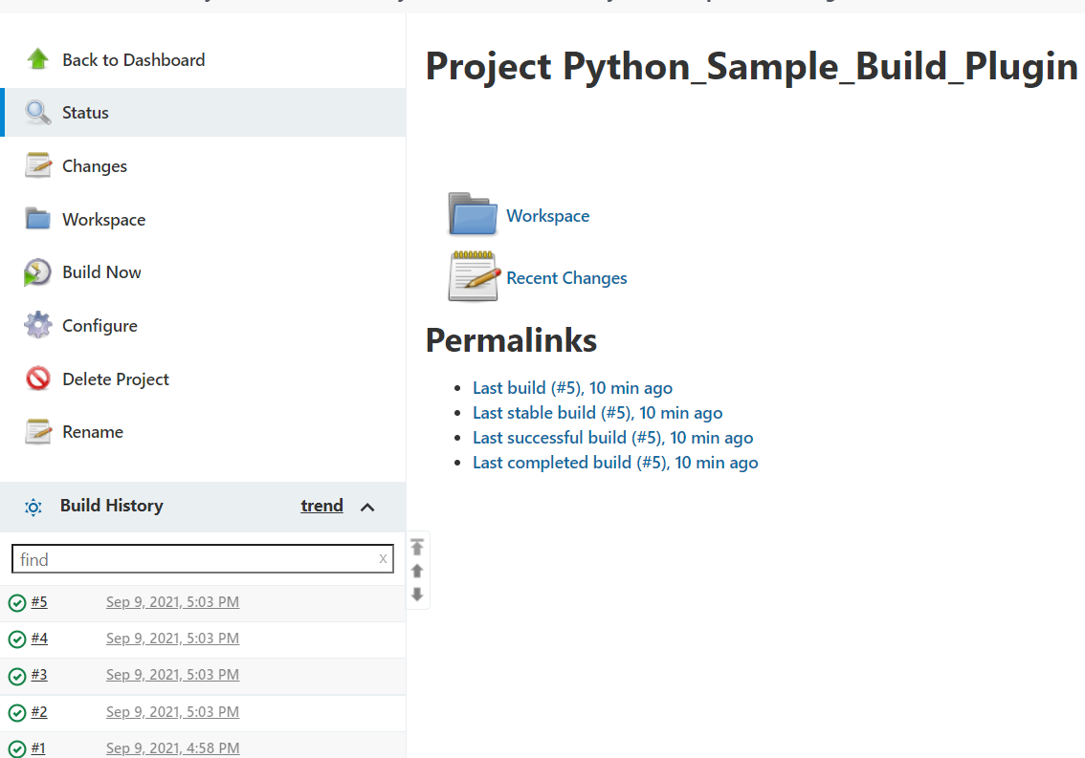

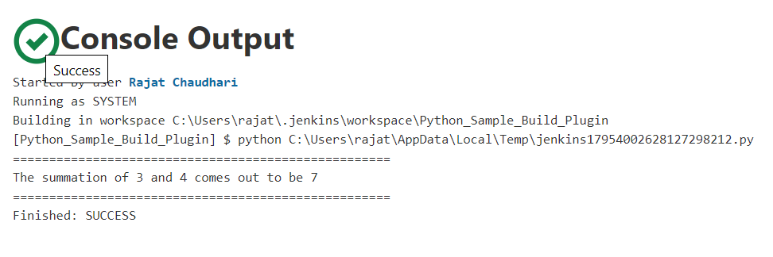

**Now Java Program (Explicit Programming)**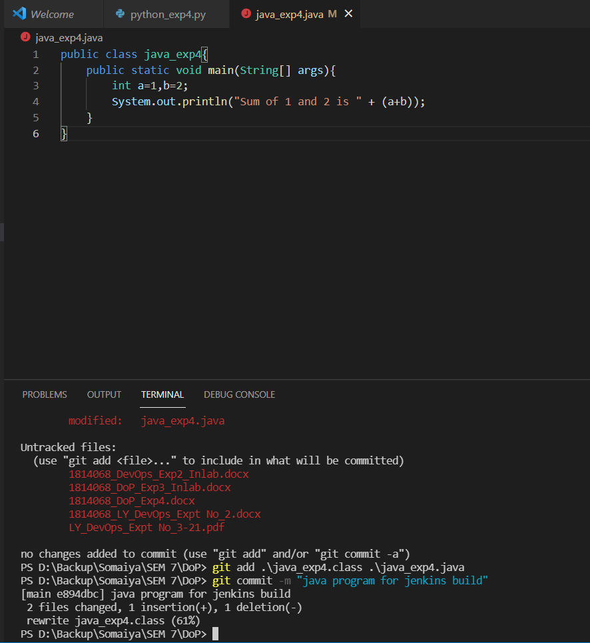

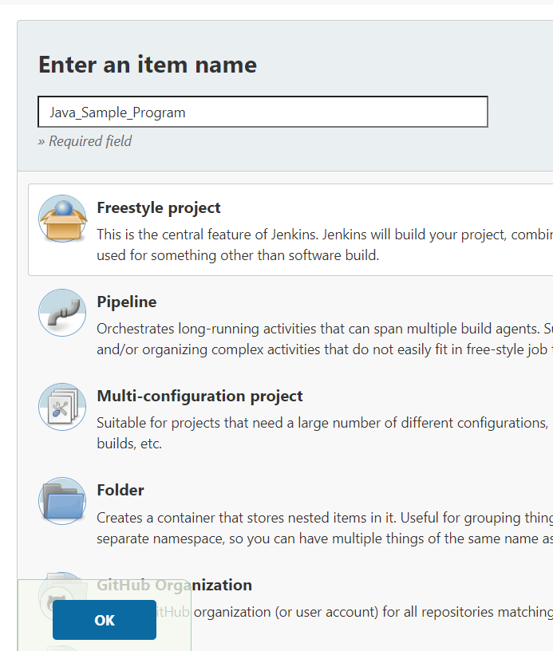

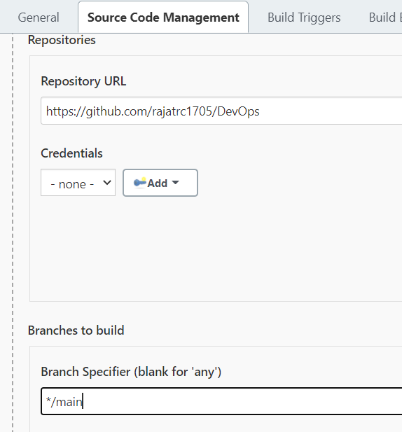

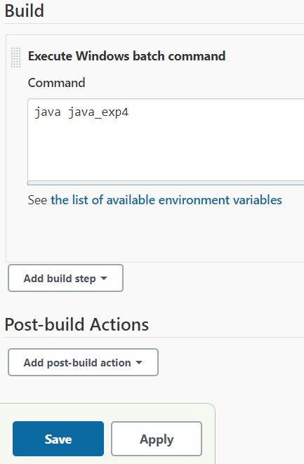 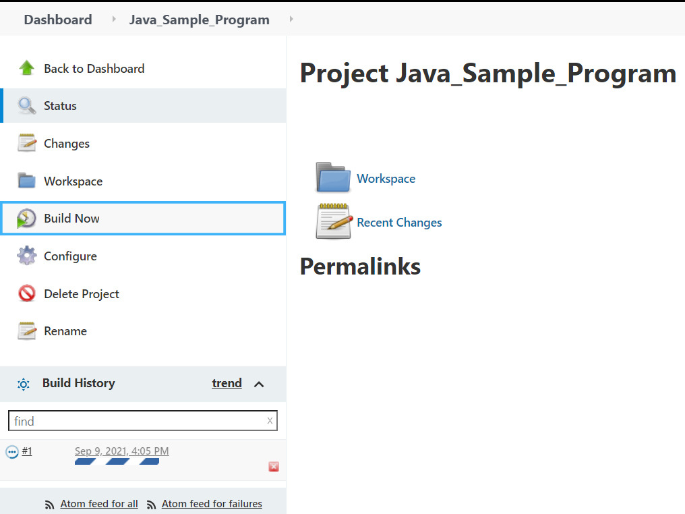

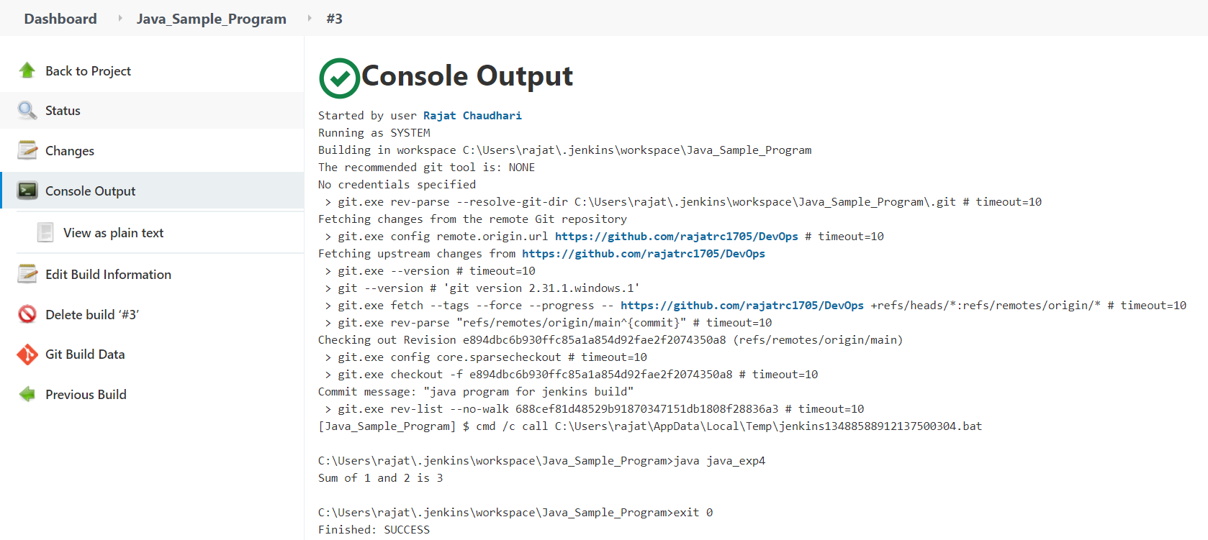

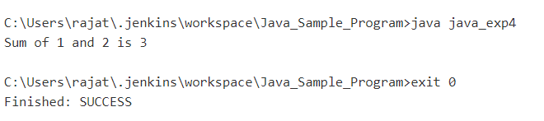

# Questions:

1. Explain difference between system configuration and global tool configuration.

**Answer:**

System Configuration: In this, we can manage paths to the various tools to use in builds, such as the versions of Ant and Maven, as well as security options, email servers, and other system-wide configuration details. Jenkins will add the required configuration fields dynamically when new plugins are installed.

Global Tool Configuration:  configure various tools that we need to utilize at the time of creating a build job, for example, Java, Ant, Maven, and so on.

# Outcome s:

CO3: Comprehend the effective code building and testing process.

**Conclusion: (Conclusion to be based on the Results and outcome s achieved)**

In this experiment we learned how to effectively build code (in both Java as well as Python languages) in Jenkins environment. We did code building using implicit and explicit programming methods for Python.

**Grade: AA / AB / BB / BC / CC / CD /DD Signature of faculty in-charge with date**

**References:**

**Books/ Journals/ Websites:**

1. <https://www.tutorialspoint.com/jenkins/index.htm>
2. https://[www.guru99.com/create-builds-jenkins-freestyle-project.htmlhtml](http://www.guru99.com/create-builds-jenkins-freestyle-project.htmlhtml)
3. Effective DevOps: Building a Culture of Collaboration, Affinity, and Tooling at Scale, Jennifer Davis, Ryn Daniels, O'Reilly Media June 2016.
4. Practical DevOps: Implement DevOps in your organization by effectively building, deploying, testing, and monitoring code,Joakim Verona, Packt Publishing, 2nd Edition,2016